Memo for replotting Fig3, 4, 5 with modified Amax value and better choice of beta and Km value

Workflow:

1. Use the current AT value for each SNF model to examine the beta-Km diagram, and determine the best beta and Km for the model with N=3. For N=3 to have oscillation, Kd likely needs to assume a small value. Because longer loops increase robustness of oscillation, one would expect the same beta and Km to work for N=4,6,8,10. Altogether, beta and Km need to be determined for 6 different cases: 0L3, 0M3, 1L3, 1M3, 2L3, 2M3.
2. Regenerate Figure 3 based on the beta and Km chosen in Step 1.
3. Based on the beta and Km values in Step 1, for 0L8, 0M8, 1M8, 2M8 models, calibrate AMAX for NNF and PNF.
4. Use the beta, Km determined in Step 1 and AMAX determined in Step 3 to generate Figures 4 and 5.

Step 1 Determine beta and Km values

1. Determine beta & Km for 0MN model

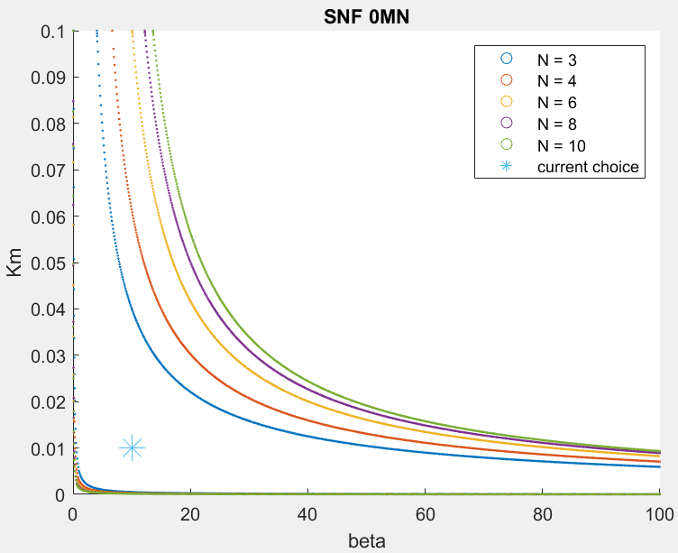

beta=10, Km=0.01, param Kd=0.00001, At0=0.1

1. Determine beta & Km for 1MN model

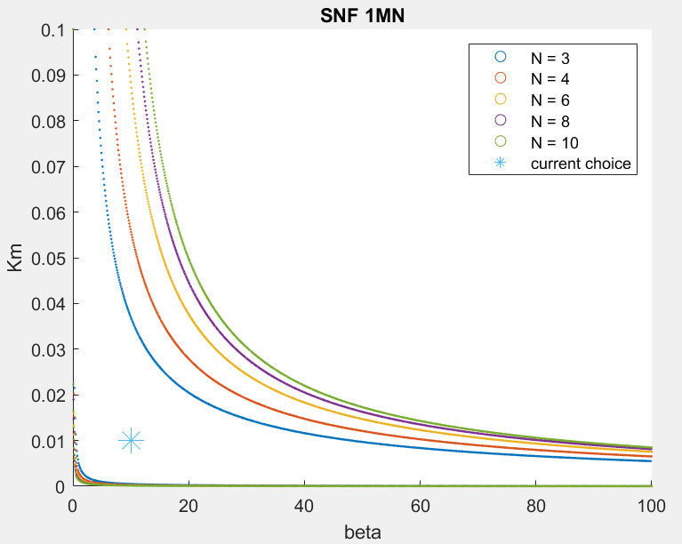

beta=10, Km=0.01, param Kd=0.00001, At0=0.1

1. Determine beta & Km for 2MN model

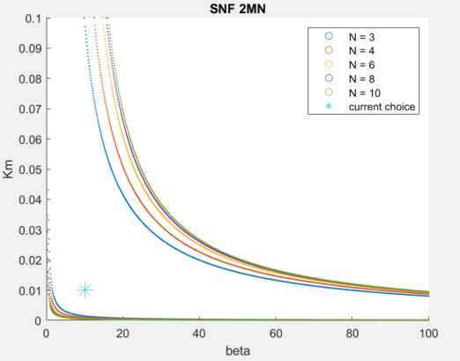

beta=10, Km=0.01, param Kd=0.00001, At0=0.1

Step 2 Regenerate Figure 3 with beta=10, Km=0.01

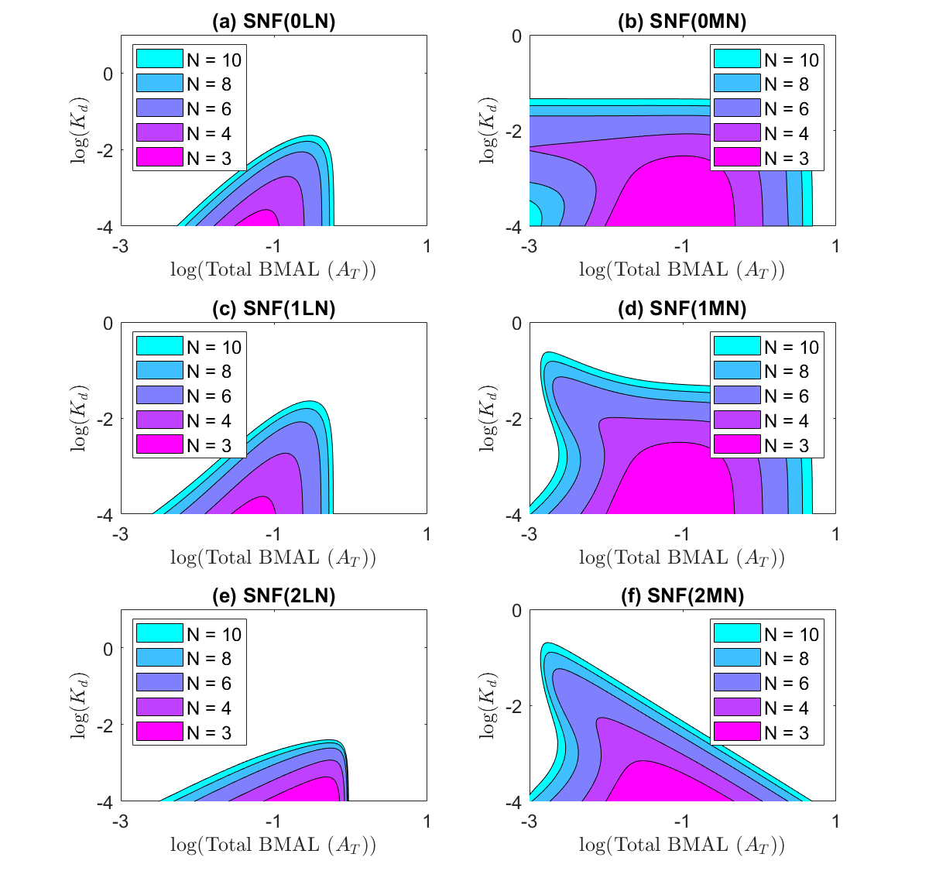

Step 3 For 0L8, 0M8, 1M8, 2M8 models, calibrate AMAX for NNF and PNF.

Draft figure format

# Figure 4. Two-parameter bifurcation diagrams.

|  |  |
| --- | --- |
| (0L8)  SNF, NNF, PNF  FCATR versus FCRTR | (0M8)  SNF, NNF, PNF  FCATR versus FCRTR |
| (1M8)  SNF, NNF, PNF  FCATR versus FCRTR | (2M8)  SNF, NNF, PNF  FCATR versus FCRTR |

# Table S4. Parameter values used in the model simulations in Figures 4, 5 and Figures S3-S5.

|  |  |  |  |  |  |  |
| --- | --- | --- | --- | --- | --- | --- |
| Panel: | 4a | | | 4b | | |
| **Param** | **SNF**  **(0L8)** | **NNF**  **(0L8)** | **PNF**  **(0L8)** | **SNF**  **(0M8)** | **NNF**  **(0M8)** | **PNF**  **(0M8)** |
| *K*d | 0.001 | 0.001 | 0.001 | 0.01 | 0.01 | 0.01 |
| *K*A |  |  |  | 0.01 | 0.01 | 0.01 |
| *K*m |  |  |  | 0.01 | 0.01 | 0.01 |
| *β* |  |  |  | 10 | 10 | 10 |
| *A*T | 0.1 |  |  | 0.1 |  |  |
| *A*MAX |  | 0.18 | 0.24 |  | 0.14 | 0.15 |
| *δ* |  | 0.2 | 0.2 |  | 0.2 | 0.2 |
| *V*MAX |  | 5 |  |  | 5 |  |
| *R*MAX | 5 |  |  |  |  | 5 |

|  |  |  |  |  |  |  |
| --- | --- | --- | --- | --- | --- | --- |
| Panel: | 4c | | | 4d | | |
| **Param** | **SNF**  **(1M8)** | **NNF**  **(1M8)** | **PNF**  **(1M8)** | **SNF**  **(2M8)** | **NNF**  **(2M8)** | **PNF**  **(2M8)** |
| *K*d | 0.1 | 0.1 | 0.1 | 0.1 | 0.1 | 0.1 |
| *K*A | 0.01 | 0.01 | 0.01 | 0.01 | 0.01 | 0.01 |
| *K*m | 0.01 | 0.01 | 0.01 | 0.01 | 0.01 | 0.01 |
| *β* | 60 | 60 | 60 | 60 | 60 | 60 |
| *A*T | 0.1 |  |  | 0.1 |  |  |
| *A*MAX |  | 0.3 | 0.15 |  | 0.4 | 0.135 |
| *δ* |  | 0.2 | 0.2 |  | 0.2 | 0.2 |
| *V*MAX |  | 5 |  |  | 5 |  |
| *R*MAX |  |  | 5 |  |  | 5 |

1) NNF, SNF, PNF 0L8 models

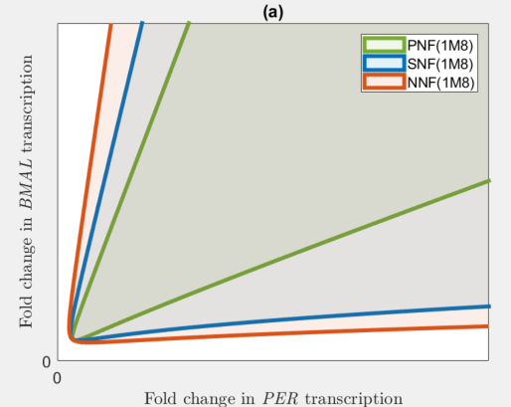

2) NNF, SNF, PNF 0M8 models

2) SNF, PNF, NNF 0M8 models

Recalibrate Amax with beta=10 and Km=0.01

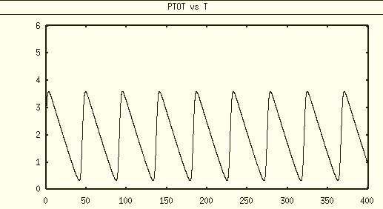

SNF 0M8 Ptot max =3.60, min=0.33, mean~1.97

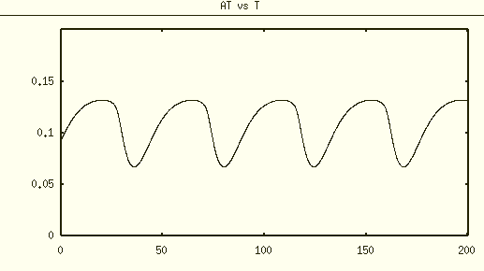

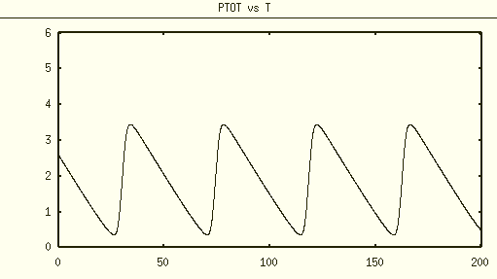

NNF 0M8 with param Kd=0.01, delta=0.2, VMAX=5, AMAX=0.14

Choose beta value with Km=0.1

1) SNF 0MN beta=4

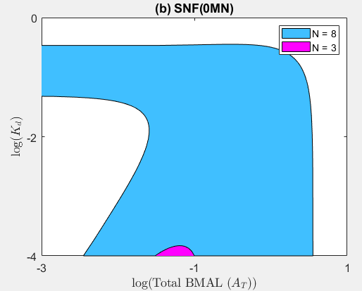

2) SNF 1MN beta=3

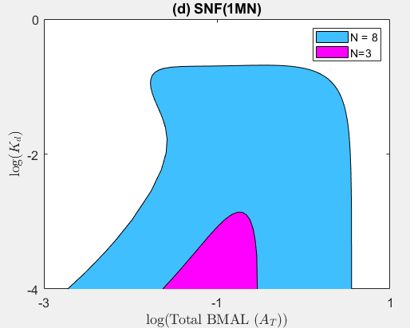

3) SNF 2MN beta=9

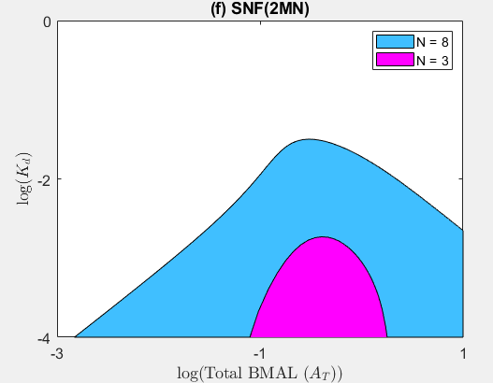

PNF 0M8

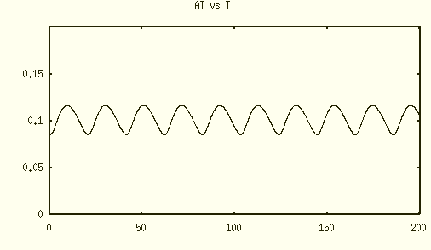

param Kd=0.1, delta=0.2, RMAX=5, AMAX=0.18

param beta=4, Km=0.1

NNF 0M8

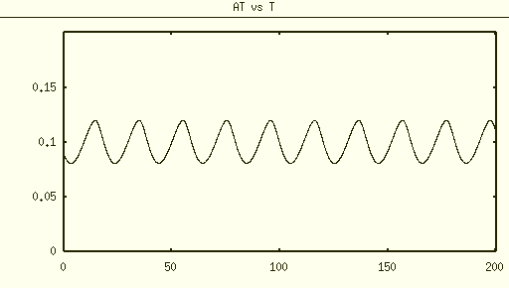

param beta=4, Km=0.1

param Kd=0.1, delta=0.2, VMAX=5, AMAX=0.23